L2 or L3 or tests name: PAM Architecture & Engineering (design)
Legal entities in scope: DBAG, ExR, EFAG, ECAG, CBF, CH, CBL, LuxCSD, CI, CS.
L2 AU-111-02-PAM Architecture & Engineering (design)

Test(s) according to RCA:
Reference: DORA Chapters – 2(Arts: 6, 9) – supported by RTS – RMF: Chapter 2 (II), RTS Articles: 19, 20, 21

(TP1) Assessment of offboarding controls for privileged accesses not tied to AD account:
a) Identification of privileged access (focus on potential DB level) that is not tied to an AD account
b) Assessment of controls in place to ensure the requirements for leavers is adhered to for such privileged accounts

(TP2) Assessment of privileged accounts on application level.
a) Access the identification of accounts and application level that fulfill the definition of privileged accounts.
b) Identify sample systems where such accounts are potentially existing
c) Assess how such privileged accounts are identified and classified in the respective authorization concepts
d) Identification controls in place and assessment of the effectiveness of the controls for such accounts

(TP3) Assessment of allocation of T0 & T1 access rights:
a) Sample critical systems and related T0 & T1 access rights
b) Identify all approved access rights and evaluate the appropriateness of their justifications.
c) Assessment, if developed access rights are in accordance with the roles and responsibilities and least privilege principle.
d) Challenge the assignment of the rights in the privileged account versus the assignment in privileged personal account

(TP4) Assessment of the privileged access for the systems, not onboarded with PAM:
a) Identification of the systems, not covered by PAM.
b) Identification of the critical systems and the critical access rights.
c) Overview the controls in place (including compensative control, for example 4 eye principle, segregation duties, Log management and etc.)
d) Assessment of the risk and potential impact and likelihood.

(TP5) Assessment of the integration of IIQ with PIM and assessment if technology works as intended:
a) Overview of existing documentation.
b) Assessment of degree of integration PIM and IIQ
c) Overview and mapping of the roles identified in IIQ and Azure.
d) Assessment if role management is done through IIQ system and data is synchronized.
e) IA to also check for transparent escalation to the right committee of the situation and timeline.

Audit procedures/source:
- Information directly requested from auditee (via e-mail or call) or extracted from provided documentation during preparation phase.

Conclusion:
Ok, no exception identified
Not ok, exception identified

Internal audit (LS/ÖA) has performed the following Audit procedures:

-------------------------------------------------------
Summary of work done:
-------------------------------------------------------

AP | Work done | Result
TP1 | IA performed overview of priviledged accesses management focused on database access-right management. Following assessment planned to cover, onboarding of DB to AD and PAM, also offboarding controls. According to the interviews with the stackeholders, part of the DBs are not integrated with AD and the PAM systems. Hence following DB lack of proper controls in place.  IA requested the all DB, including users and respective accesses to specifically identify the privilaged accesses. Also, IA collected list of offboarded employees, to doublecheck with DB user-access rights and identify unauthorised accesses. Comperasion with both list underlined following topics :  - According to the provided file access to the productions DBs, where the user left the organization or is long time leave. Following accesses are arranged as follow :  - IA identified 1214 records of the access to the production databases have been identified from the users, who either left the organization or in long term leave. Following records are regarding access from 56 unique users, to varius production environments.  - 44 of the records have been identified by 12 users, which are grantet priviladged access to production environments.  Conclussion - NOT OK  According to further discussion, following topic is related to onboarding of the systems with IIQ and discovery of the users and follow up recertification/reconsiliation. Following topic is already identified in AMELI validation package – “IAM-3, IAM-2". No further actions are required.
TP3 | IA performed assessment of T1 & T0 accounts. Following assessment included sampling critical systems to identify T0 and T1 accounts are aligned properly, of excessive user right were used. For follow up assessment, following applications have been Sampled:  - AID131 - INTACT  - AID1110 – Citrix FAS  - AID1109 – Citrix Netscaler  - AID595 – SCCMA  - AID768 – Terraform Enterprise  - AID283 – Artifactory  - AID131 - INTACT – business application :  - According to the DAC, following deficiencies have been identified – around 120 t0, t1 and t2 roles are registered in the system. Around 90 accounts have no members in it and roles where only single members are registered. The proper description of the roles wasn’t available in the system. – Conclusion Not OK  - AID1110 – Citrix FAS :  - According to the DAC, following have been identified – system contains 40 different T1 roles. Following roles are either empty or with identical users. According to the owner, for every server supporting the application, there is 2 roles – 1) local admin role and 2) RDP Admin role. At this stage, where stakeholders have requested the access, following accesses were granted to them. The groups, where request wasn’t requested the access haven’t been granted to anybody and until then the group will be empty. According to AI, following arrangement complicates the role allocation and user management process. As for additional control, every change executed in the system is notified to all stakeholders, following is native function of the tool.  Not ok – in terms of role management.  - AID1109 – Citrix Netscaler  - According to DAC, following application is “still in release” and DAC doesn’t represents the roles and members. According to the authorization concept following application contains T1 accounts, for administrative use. The system is onboarded with CyberArk and privileged use system is controlled. Additionally every change executed in the system is notified to all stakeholders, using native function of the tool.  Conclusion – DAC integration Not OK.  Roles – OK  - AID595 – SCCM :  - According to the DAC, application contains T0, T1 (T2) and T3 roles. After further examination, 5 of the T0 roles have been identified, without the single member in it. Roles as follows:  - AID595 (SCCM) - PROD - Tier0 - Windows Remote Desktop User  - Windows Server OAAD - REMOTE USER access to FRPSCCM01  - Windows Server OAAD - REMOTE USER access to FRPSCCM01-IT  - Windows Server OAAD - REMOTE USER access to FRPSCCM02  - Windows Server OAAD - REMOTE USER access to FRPSCCM02-IT  For T1 roles we identified that there are around 105 T1 (including T2) Roles. For the number of the T1 roles, audit couldn’t find any members. Also, multiple T1 roles were identified with similar members. Based on following information, IA highlights the potential need to recertification roles. Following can be as a result of merging the multiple roles, because of serving the similar purposes or deletion of the roles, because of absence of necessity (no members for specific roles). – Not OK  In some cases, description doesn’t clearly describes what is the purpose of the role. Not OK  The system is additionally onboarded with other security tools, which mitigates risks of abusing the rights in the system, following is covered with SIEM and Log management controls.  According to the system engineer responsible for the application, the redesign of the application is currently ongoing in terms of SAFE and documentation is in progress which will represent tiering.  Conclusion – Not OK  - AID768 – Terraform Enterprise  - According to the DAC, system contains 6 main priviladged (T1) accounts, following roles have individual purposes, hence membership of the team is different for all of them. The description of the roles are provided as necessary. The system is onboarded with PAM and access to the system is done in secured manner. For the production environment, there are no T3 accounts, T3 accounts exist only for the test environments. As for additional controls, logs are recorded and informal 4 eye principle exists (communication between the team).  Conclusion –Ok  - AID283 – Artifactory  - According to the DAC, system contains 4 mains privileged T1 accounts, No T0 accounts have been identified. Every role have individual purposes and contains with different users. The description for the registered roles is provided properly and clearly represents designation of the role. There are more than 30 T3 roles, according to the description some of them have limited administrative privileges, within limited functionalities (for example limited to the specific repository). Based on the information provided by owners of the system, the logs for the performed actions are recorded. According to the owners, the system transition to the cloud is planned and being executed, following changes would affect on roles and most of the T3 accounts will be erased.  Conclussion –OK  According to the overviews done by IA, including overview of the DAC system, Authorization concept (document), and interviews following have been identified. Applications registered in DAC system needs to be overviewed and the records of T1 and T0 roles must be updated. Specifically, the roles with the same purposes, including privileged rights and members of the users must be reviewed and adjusted accordingly (only assets specific server is different). Empty privileged roles must be overviewed and merged/erased. According to the audit the high number of roles, would be ineffective for management, which may rise risk of unauthorized access, difficulties of recertification and errors in the system.  Conclusion: Not Ok.  Nevertheless, IA revealed that following topic is already covered in the scope of AMELI validation, particularly package “IAM-1” covers following topic. No further actions are necessary. | as
TP4 | a) Identification of the systems, not covered by PAM.  b) Identification of the critical systems and the critical access rights.  c) Overview the controls in place (including compensative control, for example 4 eye principle, segregation duties, Log management and etc.)  d) Assessment of the risk and potential impact and likelihood.  IA collected the report of the PAM onboarding for the assets and accounts. Main goal is to identify not onboarded assets and assess the root cause and assess the severity of the topic. According to the overall population of the assets and onboarding rate, onboarded and non-onboarded assets are in compliance with established KPIs.  After randomly overview of the applications, most of the applications include onboarding with IIQ, hence managed roles and majority of the applications are SIEM onboarded. The additional layers of the controls are presented.  Conlcusion OK
According to the preliminary information received during the audit, the IIQ was not integrated with Azure PIM roles. Hence PIM (Privilege Identity Management) roles, which are granted ab123_t1 rights were managed in Excel file and approved by head of department. Also, maximum following accounts were in violation of compliance requirement, where rights could granted maximum 14 hours. During the overview of the topics and conducted communication with the relevant stakeholders, following information has been received. The project is still ongoing, at this stage the T3 accounts have been integrated with IIQ and managed accordingly, but integration of T1 accounts is still pending.

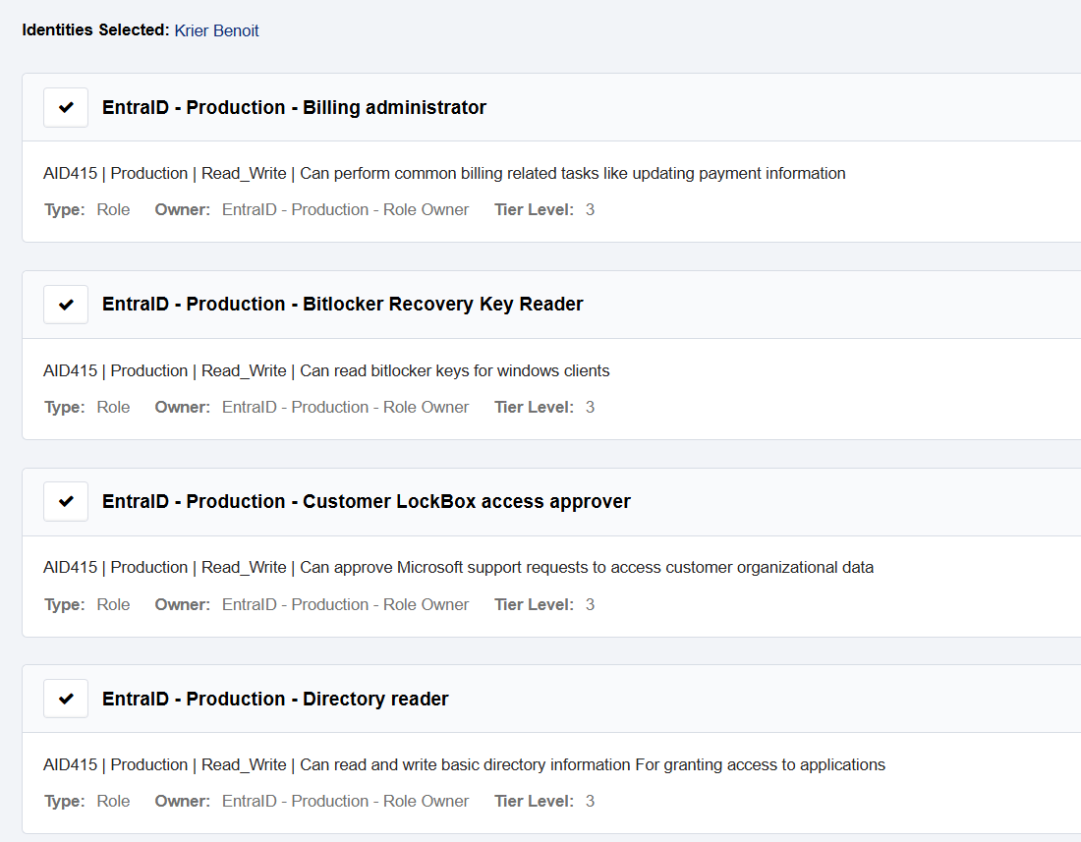

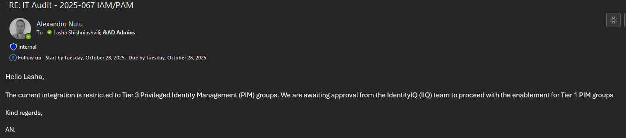

According the final review with owner of the system, regarding last updates, IIQ is fully ready to integrate IIQ with T1 accounts. According to overal timelines, the specific roles will be requested to register in IIQ, after that announcement will be done to users, to request the roles, which will be done in 2 weeks period. As overal estimation of the finalization of the process, full integration and management will be done, by end of the November.

Conclusion: Not Ok.

Caveat: All notes in this document do not represent a protocolary transcript or quotations of the meetings. They would provide an overview over the content of the meeting. Further the notes may be arranged according to the topics discussed and not based on the chronological course of the meeting.

